Comrades,
We have just been informed that our normal meeting place at Bangkok Hospital will be unavailable for the next several months.
Due to the short notice from Bangkok Hospital, we will move the location and date of our June Meeting.
Mike of Chiang Mai Smokehouse has offered his airconditioned room for our Post to meet at no charge.
Date/Time: 12 June, 10:00 to 12:00
Location: Chiang Mai Smokehouse
As a way to thank Mike for his generous offer, a social time will be offered immediately after the meeting. There will be a limited lunch menu offered and I encourage all attendees to stick around after the meeting for lunch and conversation.
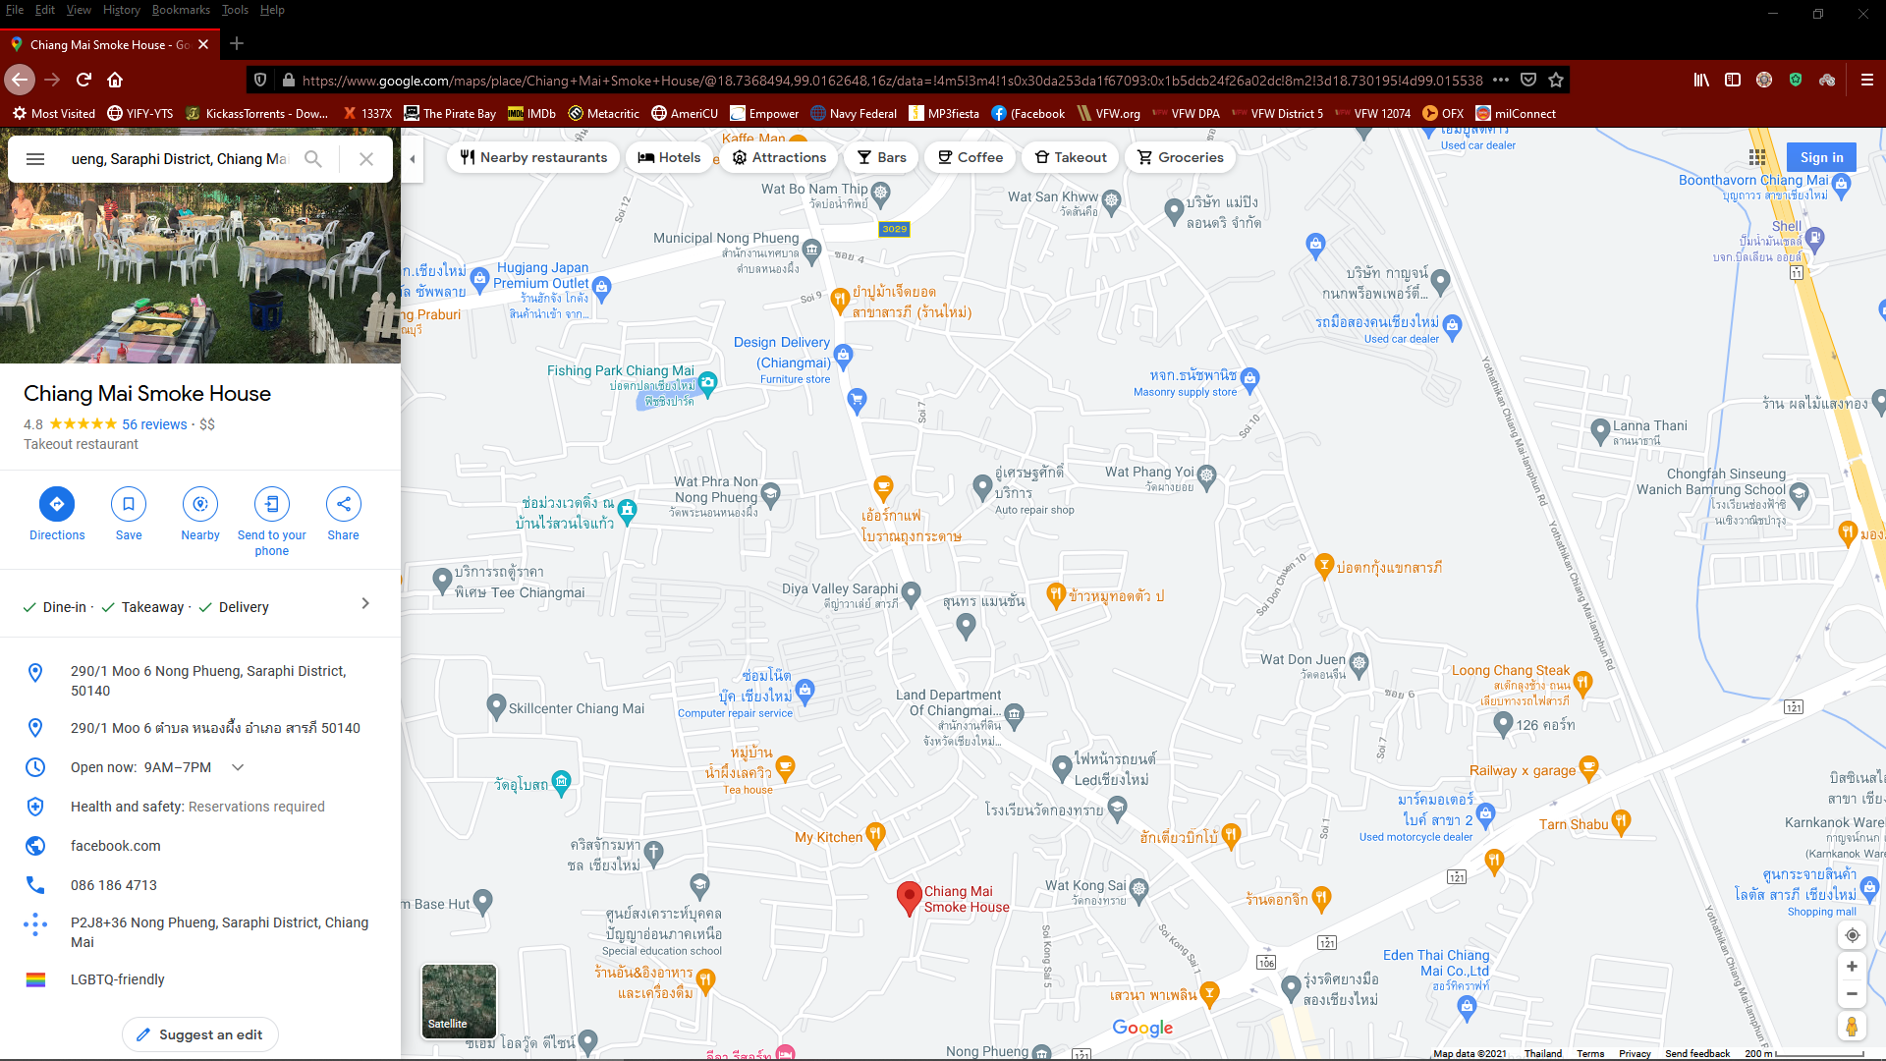

https://www.google.com/maps/place/Chiang+Mai+Smoke+House/@18.7368494,99.0162648,16z/data=!4m5!3m4!1s0x30da253da1f67093:0x1b5dcb24f26a02dc!8m2!3d18.730195!4d99.015538

