I am very happy to introduce to our Member Spotlight Terence “Terry” Harkin. Terry is an active member of VFW Post 12074, Chiang Mai, Thailand with an impressive background. Terence is one of three published authors who are members of VFW Post 12074, Chiang Mai, Thailand.
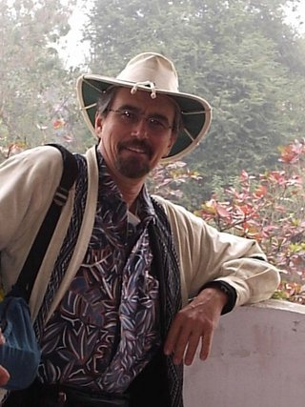
Military service:
Terence A. "Terry" Harkin served in the USAF from 1969 to 1973, starting at as an illustrator at the Department of Defense Computer Institute, Washington, DC, before requesting a transfer to Headquarters, Aerospace Audiovisual Service at Norton AFB, CA in 1970, at the time the largest motion picture production facility in the world. Terence worked there as a motion picture film editor and continued to do so from 1970-71 with Detachment 3, 601st Photo Flight at Ubon RTAFB, editing Bomb Damage Assessment footage from all over SEA, especially from F4 Phantom gun cameras and new video systems on AC-130 Spectre gunships. He worked in close collaboration with AC-130 pilots and Fire Control Officers who were recording Operation Pave Pronto over the Ho Chi Minh Trail. Det 3 briefing films were sent directly to the Pentagon and Senate and House Armed Services Committees. Terry also had the honor of writing the 1970 Squadron History of Detachment 3. He spent his final year at MAC Headquarters, Scott AFB, IL, preparing briefing films and training as a cameraman.
General background:
Terry earned a BA in English-American literature from Brown University in 1968, while also touring New England as a drummer with bands that opened for the Yardbirds, the Critters, and Jimi Hendrix. After discharge from the USAF, he used the GI Bill to earn an MFA in motion picture production at USC. While there he won a CBS Fellowship for his screenwriting, which included a 50-page movie treatment for The Big Buddha Bicycle Race that would eventually morph into two novels. Terry went on to 25-year career as a cameraman, where his credits included MASH, Quincy, From Here to Eternity (mini-series), and Seinfeld. He began returning to Thailand in 1987, and after retiring from a second career teaching high school and college English, was able to devote full time to writing. Growing up in a family full of WW II-vintage pilots, serving a year at Ubon RTAFB where the USAF were flying over a hundred sorties a day, and spending many years as a cameraman enabled Harkin to write authentically about the life of a combat cameraman at Ubon, the subject of his first two novels.

Publications:
The Big Buddha Bicycle Race (2017), a Kirkus Top One Hundred Indie Book of 2017, a Goodreads Top Ten Vietnam War Book, and winner of a 2020 Silver Medal in Literary Fiction from the Military Writers Society of America.
In the Year of the Rabbit (2021), called "essential reading” by Robert Olen Butler, Pulitzer-winning author of A Good Scent from a Strange Mountain.

Web Page:
taharkin.net

Submitted by:
Carl Manchester
Commander
VFW Post 12074
Chiang Mai, Thailand

