Jacket and Blanket Project
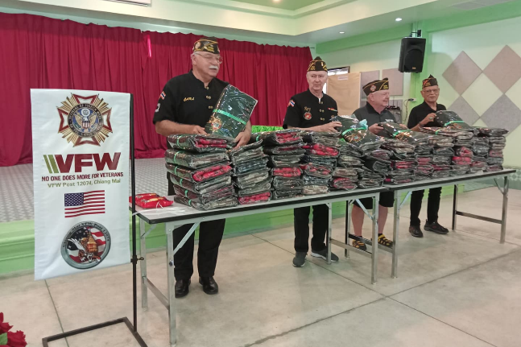

When: 4 November, 1000 hours

Where: Wat Buppharam (Wat Mee Kong Bok)
Moo 2, Tambon San Klang, Amphoe San Pa Tong, Chiang Mai, 50120
https://goo.gl/maps/jY9PZNGePu7jgVsg6

Schedule
1000 hours Thai War Veterans sign-in
1030 hours Commander, Thai War Veteran Office welcome address
Local Official, welcome address
VFW Commander, welcome address
Distribute Jackets & Blankets
Thai War Veterans “Thank You” and Photos
1130 hours Closing

