VFW Post 12074, Chiang Mai Thailand is a proud sponsor of “The Children's Shelter Foundation River Farm”

Children's Aid Project for children and young people from the hilltribes of Thailand.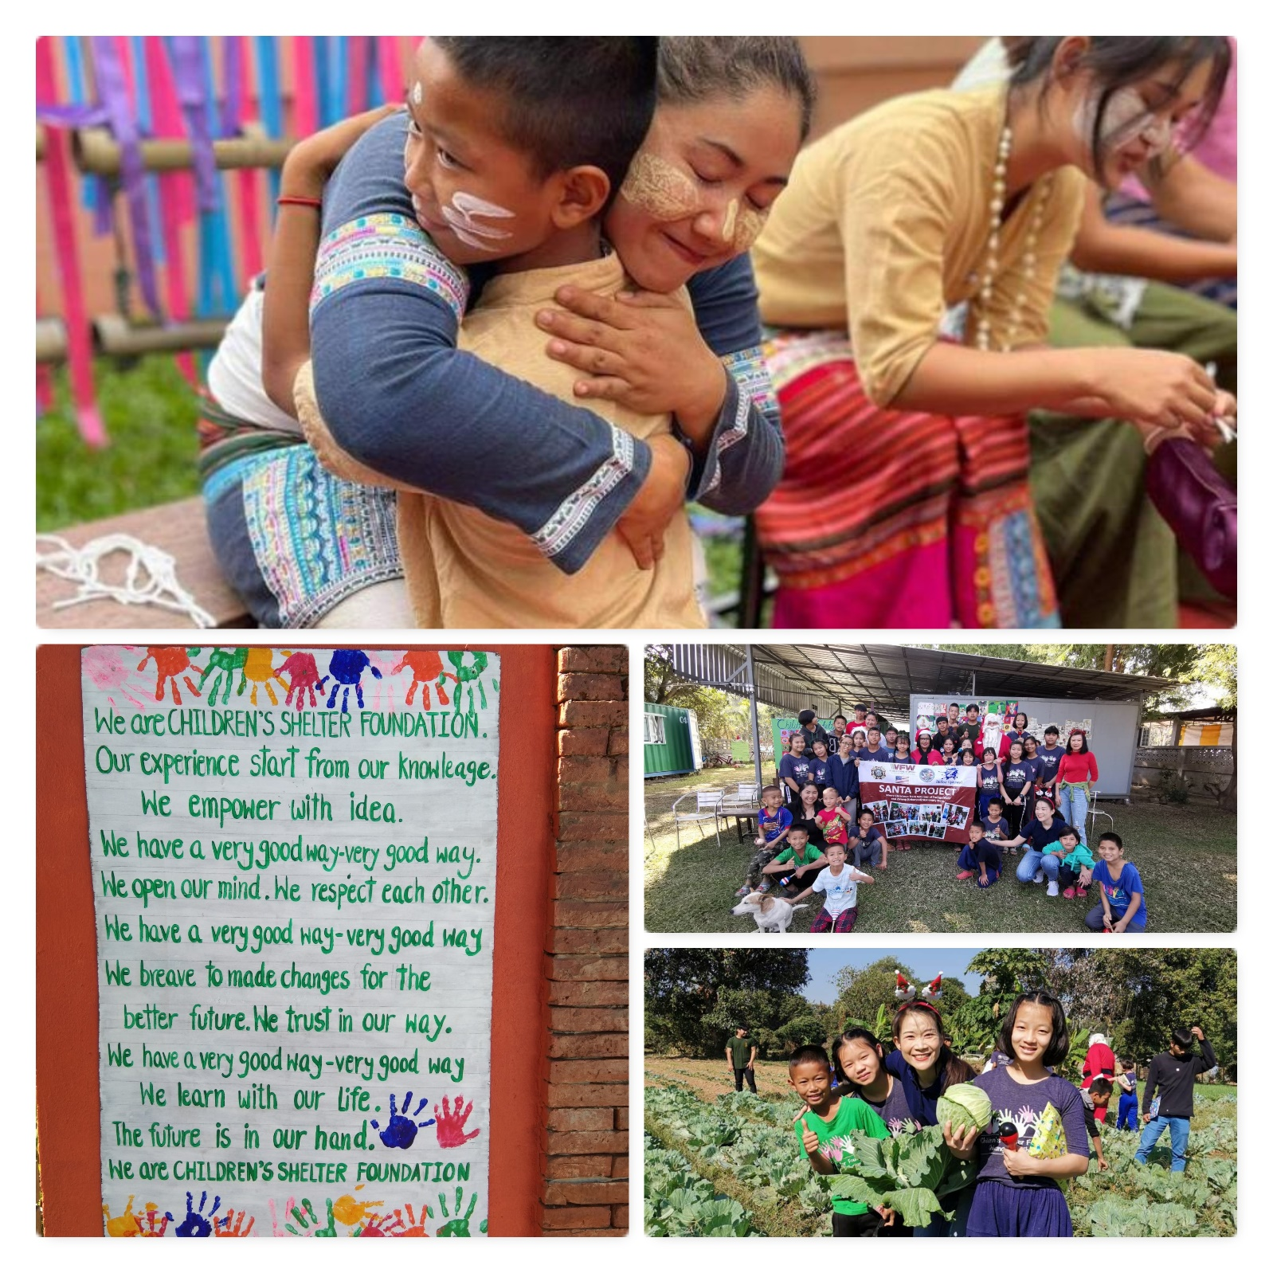
Why a project for children and young people from the mountain villages?
The hardship in many mountain villages of Northern Thailand and Myanmar is still considerable.
The various mountain peoples are among the ethnic minorities of Thailand. As Non-Thai Nationals, they usually have no legal status, and thus few rights or none at all. Depending on which tribe they belong to, they may have, for example, no ID cards, no health insurance, no right to go to school and sometimes no right of residence.
70% of people live below the poverty threshold as defined in Thailand.
The inhabitants of many villages are marked by poverty, unemployment, disease and hopelessness.
Drug trafficking and drug addiction and the associated neglect or negligent treatment of their children are still sad themes in many regions.

What is CSF's target group?
CSF's program is aimed at helping children and young people from the mountain villages of Northern Thailand and Myanmar.
The various tribes differ considerably from one another in culture, mentality, social environment and way of life, as well as in the resulting problems.
Correspondingly, the children's and young people's vulnerability has very different causes.
- Inequality of opportunity through a lack of rights
- Exposure to poverty or neglect
- Exposure to abuse
- Escape from the military (Myanmar - child soldiers)
- Drug problems of single families or whole villages
- Children without parents (orphans, unwanted children, children of deported or imprisoned parents)
- Children with untreated acute and chronic diseases

The concept
My Future - Breaking the circle of poverty
CSF has set itself the goal, using the slogan "my future", of breaking cycles of poverty and vulnerability and of working hand in hand with the children and young people to shape their self-determined and secure future.
The concept of the Children's Shelter Foundation is adapted to the requirements of Thai middle-class society as well as to the culture and traditions of the various tribes.

Family Education for Life School and Vocational Training Accompaniment into life Open doors
Under the supporting umbrella of a colorful extended family, children and young people live together along with their teachers, educators and caregivers in a loving and secure home. They grow thanks to their everyday, age-appropriate tasks within the community and receive schooling and vocational training that is both: excellent and tailored to the individual's needs.
The accompaniment of young adults into their own lives and a door that remains open for the rest of their lives complete this concept, which has proven itself for more than 10 years.
"Love * Courage * Hope
wings that carry lifelong,
good education and strong life skills
along with a large dose of self-confidence.
That is our goal for each of our children."

