**District Five Convention**

***Meeting Location:***

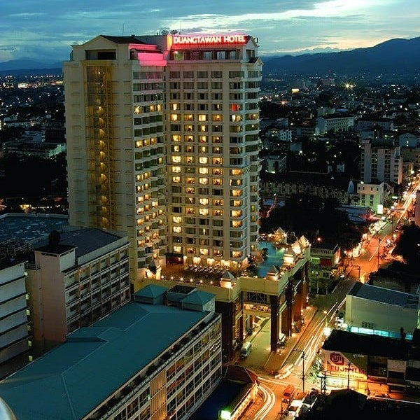

***Address:*** Duangtawan Hotel Chiang Mai

132 Loi Kroh Rd,

Tambon Chang Khlan,

Mueang Chiang Mai District,

Chiang Mai 50100

**To reserve a room,** contact Ms Thanyada

Ask for VFW Rate

Phone:0[89 700 8048](tel:+6653905000)

[thanyadath@dtw.co.th](mailto:thanyadath@dtw.co.th)

**Property overview**

* + Free Wi-Fi in all rooms
  + Outside swimming pool
  + Sauna
  + Hot tub/Jacuzzi
  + Steam room
  + Fitness Center
  + Parking
  + Airport transfers available

**Dining, drinking, and snacking**

* + 3 Restaurants in Hotel
  + 3 Lounges in Hotel
  + 1 Cafe
  + Coffee/tea maker
  + Free bottled water
  + Mini bar
  + Refrigerator
  + Room service

**All VFW members may pick up a 200 THB coupon for the social from Commander Logan or SVC Manchester at the poolside social. The coupon will be honored by the staff to reduce your food and/or beverage cost up to 200 THB.**

***Goggle Location map:***

<https://maps.app.goo.gl/PWEX4GnWdY3YK3Hp9>

**Room Types**

**Superior Room 1,400 THB Deluxe Room 1,600 THB**

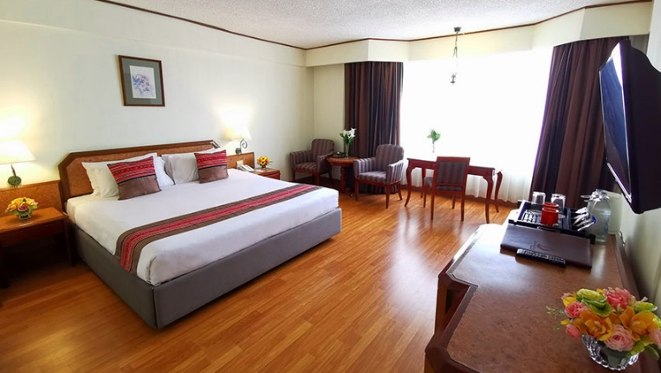 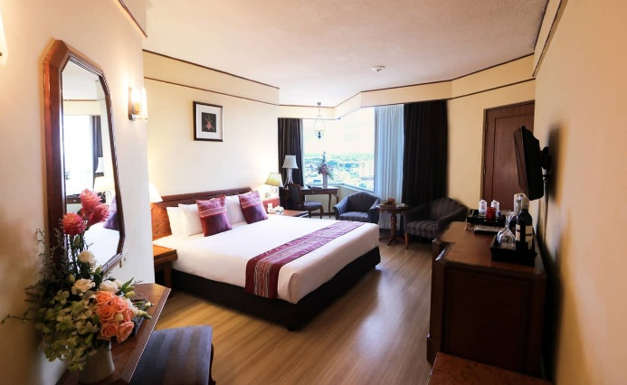

**Junior Suite 4,000 THB**

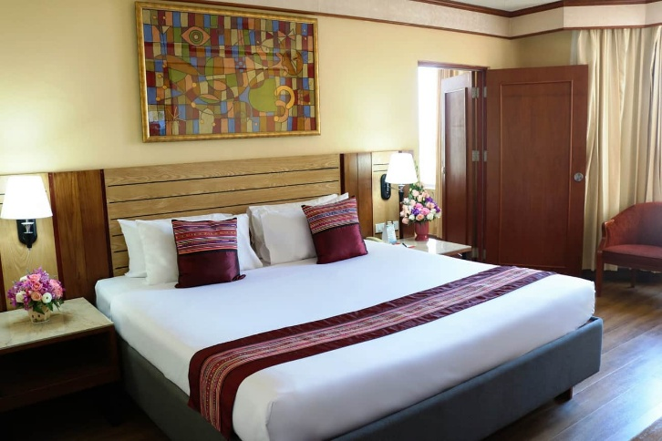 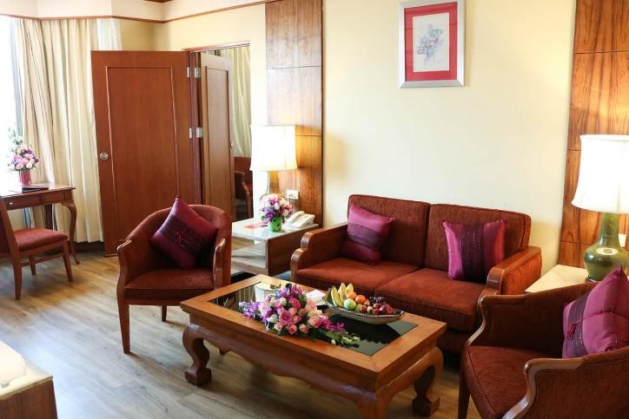

**Room Types Rates:**

|  |  |  |
| --- | --- | --- |
| **Room type** | **Size of room** | **Rate** |
| Superior Room | 36 sq m | 1,400 THB |
| Deluxe Room | 40 sq m | 1,600 THB |
| Junior Suite  Club lounge benefits for the Suite entitles entry on the 23rd floor.  Free Airport Transfer. | Bedroom & Living room  approx. 80 sq m | 4,000 THB |
|  |  |  |

The room rates quoted above are:

- Net, inclusive of 10% service charge and 7% prevailing government taxes

- Inclusive of buffet breakfast at Tawan Restaurant

- Inclusive of Wifi Internet access in guest room

**Meeting Schedule**

**Friday, 16 May 2025**

|  |  |  |
| --- | --- | --- |
| **Time** | **Event** | **Location** |
| **1500-1700** | **Cootie Scratch** | **Chiang Roong room**  **3rd Floor** |
| **1900-2100** | **Evening Social** | **Pool Terrace**  **All VFW members will have a 200 THB coupon** |
| **1900-2100** | **VFW Auxillary**  **Recuitment** | **Pool Terrace** |

**Saturday, 17 May 2025**

|  |  |  |
| --- | --- | --- |
| **Time** | **Event** | **Location** |
| **0700-0900** | **Breakfast Buffet** | **Tawan Restaurant, 2nd floor** |
| **0930-1030** | **District Meeting** | **Chiang Roong room**  **3rd Floor** |
| **1030-1045** | **Comfort / Coffee Break** |  |
| **1045-1200** | **District Meeting** | **Chiang Roong room**  **3rd Floor** |
| **1200** | **Pay as you go lunch** | **Local restaurants near hotel TBD**  **OPTIONS:**  Hotel restaurants (Korean, Chinese, Western)  Fueng Fah (Thai) AIKU Bar & Restaurant (Japanese)  Hard Rock Cafe (American)  Red Lion English Pub (Western)  Garden Restaurant (Thai)  Alice's Restaurant (Thai)  HONG's Sky Bar (Northern Thai) |